Rotherham Housing Staff Awards 2018-19

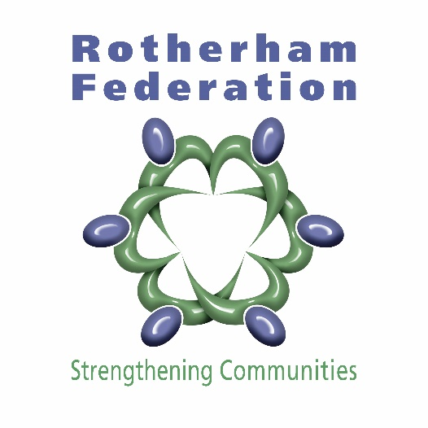
Nominations for a staff member from Rotherham Council, Fortem or Mears who have done that little bit extra to help council tenants in 2017/2018. Nominations need to be received by Friday 15th June 2018. Awards will be presented at the Tenant Conference on the morning of Tuesday 3rd July 2018 at New York Stadium

AWARDS SPONSORED BY ROTHERHAM FEDERATION

Return this card to Rotherham Federation, Springwell Gardens Community Centre, Eastwood View, Rotherham S65 1NG or email your nomination to info@rotherfed.org

Your name
Your address/Email
I confirm I am a Council tenant
Name of Staff Member You Would like to Nominate
Which Organisation Do They Work For?
Why Have You Nominated Them For An Award?

