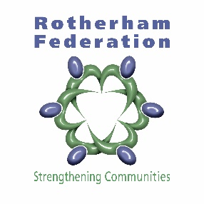
Rotherham Federation of Communities Ltd
Trustee Nomination Form 2019

We are seeking charitable trustees to join our board to enable the Federation to achieve its mission of ‘strengthening communities’ in Rotherham.

2 positions on the Trustees Board are open to election. Elections are up for 1 community of interest representative and one from Wentworth North.

Please refer to the Federation Governance Handbook and Good Governance Guide for information on the responsibilities of being a charitable trustee (contact us for copies). You can be nominated by a community led organisation (this includes Area Housing Panel members and TARAs) or by an individual who must be a resident of Rotherham.

Nominations to become a Trustee need to be received by us by Friday 25th January 2019.
All nominees will be interviewed by an Interview Panel (CEO and Chair) to assess their competency to become a charitable trustee before they can be considered for election.

Results of elections held will be announced at the AGM on Tuesday 26th March 2019 and Trustees will be on the Board for a period of three years.

Name of Nominee

Address of Nominee

E-mail
Name and signature of Nominating Person/Organisation

Statement of Why You Would Make a Good Trustee of Rotherham Federation? (250 words maximum)

I Would Represent (tick top box or write name community of interest:

Wentworth North

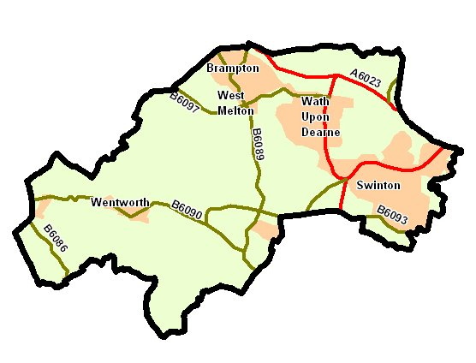

Communities of Interest

Name which one – for instance young person, disabled, BME

Please return this form to info@rotherfed.org or Springwell Gardens Community Centre, Eastwood View, Rotherham S65 1NG by Friday 25th January 2019. If you want to know more about the role please contact Steve on 01709 368515 or email steve.ruffle@rotherfed. org

Rotherham Federation of Communities Ltd (charity no.1158600, company no. 5913521)

